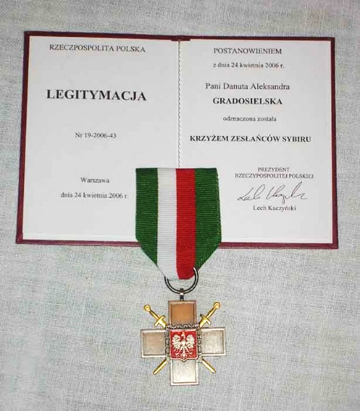

Notes on Siberian Exile Cross applications

The Siberian Exile Cross is awarded by the Polish President to those who were forcibly taken to Siberia by the Soviets during WWII.

Important: the person for whom the application is made must have been alive in January 2004, when the award was introduced. Applications can be made for persons deceased after this date.

Applications for granting the Cross to persons without Polish citizenship or permanently residing abroad are presented to the President of the Republic of Poland via Polish consular offices.

Before this, each application has to be approved/sponsored by a Polish veteran association in the country you live in. Kresy-Family can provide this for members in the UK.
Once approved, the application is passed to the Polish Consulate, which forwards it to Poland for processing.

The waiting time can be months, or years. They probably wait until they have several awards in the same area to be able to arrange an award ceremony at the Consulate.

Key points to note when completing an application form:
- The form has to be filled in by computer or typewriter. Handwritten applications will not be accepted.
- The form has to be filled in in Polish. English will not be accepted or will definitely slow down the process.
- Evidence of deportation needs to be provided.
- A copy of a current photo ID will need to be provided with the application. Eg passport, or driving licence.
- Remember: the person for whom the application is made must have been alive in January 2004.

What kind of “evidence” is needed for the application? Any of these can be used. You don’t need all. A print-out or a screen shot from any of these can be used:

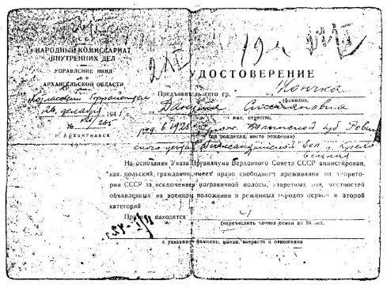
- A release document from Siberia - Udostowerenie

- A listing on the IPN Index
https://indeksrepresjonowanych.pl/int/wyszukiwanie/94,Wyszukiwanie.html

- A name on one of the evacuation lists, but note that these lists do not include military members
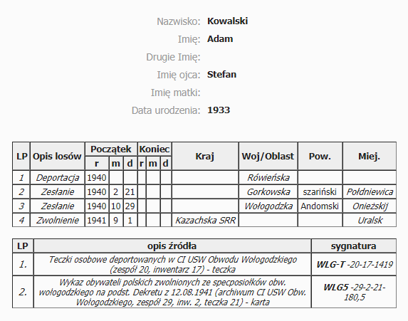
http://www.kresyfamily.com/deportation-lists.html

- A listing on the Africa and India lists
https://www.polishexilesofww2.org/lists-civilian-exiles

See also our Canadian colleagues' website – this site has many useful archival lists
https://www.polishexilesofww2.org/

- Hoover records, contact Irena Czernichowska, Hoover Institution Archives irenac@stanford.edu

- Any other appropriate personal documents

As far as we know, there is no successful way of following up an application, but you can try:
Urząd do Spraw Kombatantów i Osób Represjonowanych
ul. Wspólna 2/4
00-926 Warszawa
tel. 22 276 77 77

Details regarding the Award of the Siberian Cross:
http://prawo.sejm.gov.pl/isap.nsf/DocDetails.xsp?id=WDU20032252230
http://www.kombatanci.gov.pl/pl/aktualno%C5%9Bci/35-uprawnienia/70-procedura-nadawania-krzy%C5%BCa-zes%C5%82a%C5%84c%C3%B3w-sybiru.html

April 2020

